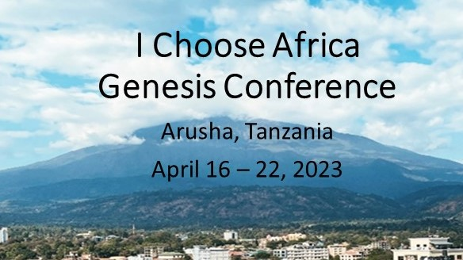
“The harvest is plentiful but the workers are few. Ask the Lord of the harvest, therefore, to send out workers into his harvest field.” – Jesus Christ, Matthew 9:37, 38
What is this conference about?
The I Choose Africa Genesis Conference will be a gathering of concerned community leaders who want to be the solution to the crisis of addictions in Africa. Topics will include why people struggle with addictions, the spiritual and clinical foundations for change, practical tools and strategies for recovery, the role of the church, and how to create community-based recovery support and job training.
Those who attend this conference will:
- Learn practical relapse prevention tools and strategies from the Genesis Process by Michael Dye
- Learn how to create community-based recovery and farm-based job training
- Learn how the church can be a hub of recovery support for their communities
- Make new friendships and find support with like-minded African community leaders
- Spend time in prayer and brain-storming of ideas of steps to bring recovery to communities
- Receive a Genesis Process workbook, Training Manual, and workbooks for starting recovery programs
Who are the Presenters?
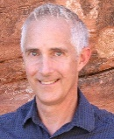
Dean Perry, President of Genesis Process International, MDiv, CADC – Dean has been working with recovery programs and addictions counseling since 2000. Before that he was a pastor and engineer. He has started residential programs in the UK and the US, including his home city of Las Vegas. Dean has also started recovery ministries in 5 churches. Currently he trains recovery counselors internationally and serves as a consultant for residential programs.

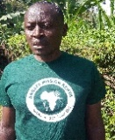
Richard Matundura, Angaza Mission Kenya CBO Director and Genesis Africa Liaison. Richard is a psychologist and addictions coach with years of experience with community substance and recovery in Kenya. He currently coordinates all genesis programs in Africa.

What we will cover: (the lectures and group discussions will be in English)
In the mornings Dean Perry will teach what is broken spiritually and clinically with addictions, what it takes to be able to change, and practical tools and skills to use for recovery from the Genesis Process counseling. He will also talk about the role of the church as a place of God’s grace for healing and hope.
In the afternoons Richard Matundura will be answering the question most addicts ask, “What happens after recovery?” He will also talk about how to do recovery work with, prisoners, and single mothers and widows, and their special needs.
We will also have time for worship, prayer, brainstorming ideas for moving forward, and time to relax and enjoy the beautiful area of Arusha.

What is the Genesis Process Counseling?
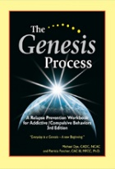
The Genesis Process is an integration of Biblical principles, proven relapse prevention techniques, cognitive therapy, and the latest research in neurochemistry. This process has proven successful in maintaining long-term recovery in clinical trials and recovery programs. It is one of the most effective relapse prevention tools in the world. Click on the links to find out more on the website Genesis Process and watch an introductory video by the author: Relapse Prevention Training
Accommodations and Venue
The White House Hostel in Arusha will provide our lodging and venue for training. Genesis Process International will be covering costs for room and board for the week as we enjoy African cuisines and Music. The following link contains more information about the White House hostel White House of Tanzania
How to Attend
The I Choose Africa committee is looking for 25 people from up to 7 different African countries who are committed to launching Genesis recovery in their communities. The committee will Those who wish to attend must:
- Be able to pay for their own visa and transportation to and from Arusha.
- Complete the application found at the link: Arusha Genesis Conference Application. The deadline to apply is February 28, 2023, and the selections will be made the first week of March. If you are chosen to attend, we will send information for travel and applying for the visa.
- If selected to attend, be able to pay a $5 USD registration fee.
In case of any questions, kindly contact:
Richard Matundura at What’s App: ±254721722956 or makenyarich@gmail.com
DNG TANZANIA at What’s App +255787756802 or +255766266555 or Tizo@dng.or.tz or Info@dng.or.tz

